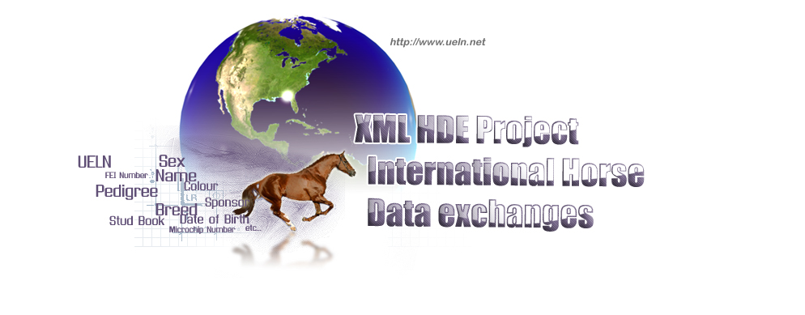
WORLD HORSE IDENTIFICATION, REGISTRATION & DATA EXCHANGE COMMITTEE

Minutes of the working group session (+ attached PowerPoint presentation)
Brussels (Belgium), Tuesday 24th of June 2008

Attending :

- Catherine de Coulon – FEI
- Dominique Delcourt – FEI
- Bruno Behier – FEI consultant
- Jean-Pierre Devos – President of the Belgium National Confederation
- Nick Wallbridge - DEFRA (NED)
- Donna Yates – DEFRA (NED)
- Rik Van Miert – WBFSH vice-president
- Deirdre Marty – IHB
- Peter Harvey – IHB
- Unn Reierstad – Norwegian Warmblood
- Xavier Guibert – Les Haras Nationaux
- Bérengère Lacroix - Les Haras Nationaux
- Stéphane Borie – Les Haras Nationaux

- Welcoming of the participants

The WHIRDEC meeting took place at the Belgium National Confederation. It was an intermediate meeting before the next WHIRDEC meeting in November (after the WBFSH GA).

- The different discussions of the meeting

  - The European Identification Regulation (6th of June 2008)

The EU regulation about identification is now adopted. It should take effect on the 1st of July 2009. This EU regulation makes the UELN mandatory, proposes microchip as an identification tool, but permits members states to choose to use other methods which could replace the microchip. (OJEU of the 7th of June 2008)

  - News about the FEI (Dominique Delcourt)

FEI21 project should finished for the 31st of October 2008, it started in summer 2007. FEI develops Webportal used for public. Presentation of the different releases (cf DD ppt presentation). Some modules have already been delivered : Calendar and Horse. The UELN part of the project has been planed in August (18th of August to 12th of September) with the data exchange module.
FEI will develop WebServices in order to exchange data with Stud-books for horses’ data and with National Federations for riders’ data.
Participants asked questions about the UELN on screens. Who is allowed to see the UELN or the horse number? Same questions about people.
Introduction of the keeper notion for the FEI. The keeper is the person in charge of the horse as the owner until now.
About microchip, it is not compulsory for competing horses; the FEI will use it as much as they can. Microchip could replace identification, but in the same time a horse can have several microchips (so we need several fields for microchips).

  - Talks about needs in order to connect the database of a Stud Book on another one (or FEI DB) via the UELN/XML exchange Website:
    - Connection between FEI, NF and Stud-books:

Explanations from Xavier Guibert about the diagram:
→ data coming from NF go to FEI
→ data coming from SB go to FEI

Data from riders and horses are separated, NF’s are interested in performances of their own riders and SB are interested in performances of their own horses. FEI remains the only database containing information on all riders and all horses, and is alone to be able to issue rankings concerning riders and horses.
FEI will give information back as long as the organisation gives data first.
About performances, there are different ways to classify and to establish rankings, so FEI needs more details. It can be by prize money, by Sire, by points, by grandsire …

Performances
FEI
SB m
All international
RIDERS
FN n
All international HORSES
FN n
RIDERS
performances
SB m horses
Performances
SB m
HORSES
FN n
RIDERS

    - Technical part (Internet DB, WebServices…):

Explanations by Stephane Borie (cf ppt of presentation).
Presentation of WebServices to exchange data.

On the UELN WebSite, it is possible to use XML exchange to test with login: demo
password: demo
Improvements and corrections on the UELN WebSite (cf SB ppt).

    - Presentation and principles of reference tables:

- Coat Colours table.

Each database should link its own colour table to the FEI colour table which could be the reference. FEI has to know first which colours have to be in the definitive list. We propose to add a field to put detail about the colour if necessary.

-Breeds and SB’s table.

In the table, UELN has to be added and an email sent to organisation recognized by the WBFSH in order to complete missing abbreviations in a first time. Then the table will be send to the FEI and inserted in UELN website.

  - Reflection on 2008 developments

    - International performance module :
When the FEI project will be at this step, we could set up a WebService to exchange data. The goal is to present it at the WBFSH GA in November.
    - Others developments:
Example of data which could be exchanged in the future :
- DNA for stallions and broodmares
- Progeny
- …
All others ideas are welcome!

- Miscellaneous matters.

It is important to have meetings with people working with data (“registrars”) rather than only with presidents or general secretaries of Stud-Books.
A student, Manon Slizewicz will work on the UELN project from the 7th of July to the 12th of September 2008. Her job will be :

  - To help members who want to connect to the UELN website

  - To work on the preparation of the next WHIRDEC meeting in November

  - To work on the research of subsidies to develop the project

