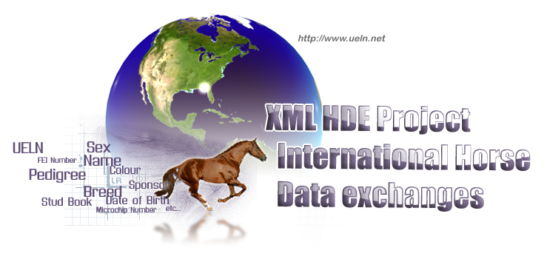
WORLD HORSE IDENTIFICATION, REGISTRATION & DATA EXCHANGE COMMITTEE

Minutes of the work-meeting
Lyon (France), 5th of November 2008

Participants:

- Xavier Guibert (Haras nationaux International)
- Daniel Taysse (Haras nationaux DSI)
- Caroline Teyssier (Haras nationaux SIRE)
- Bérengère Lacroix (Haras nationaux International)
- Stéphane Borie (Haras nationaux DSI)
- Paul Marie Gadot (France Galop)
- Pedro Rey Alvarez (Pure Spanish Horse)
- Arancha Rodriguez Sainz (Pure Spanish Horse)
- Danielle Arts (KWPN)
- Dorota Lewczuk (PAS-PMBA)
- Marie-Noelle Proutheau (French Ministry of Agriculture)
- Andrzey Stasiowski (Polish Horse Breeders Association)
- Anna Cuber (Polish Horse Breeders Association)
- Bogdan Kuchejda (Polish Horse Breeders Association)
- Catherine De Coulon (FEI)
- Charles Trolliet (Fédération Suisse des Sports Equestres)
- Srudolf Schatzmann (FN Suisse)
- Stefan Habegger (Identitas AG)
- Hans-Jürg Kleine (Identitas AG)
- Martin Moser (bvet)
- Loïc Legrand (Franck Dancombe Laboratory)
- Aymeric Hans (French Food Safety Agency)
- Carlos Mendes (Cavalo Portugues de Desporto)
- Luis Vaz d’Almaba (A.P.C. Pacas Selecta)
- Henrique Fonseca Jr. (Associacao Brasileira de Criadoros do cavalo de Hipismo)
- Lisa Owens (USEF)
- Ken Ball (USEF)
- Mary Qiddens (Int. Jumper Futurity)
- Rik Van Miert (BWP and WBFSH)
- Carine Luys (VCP)
- Rudi Eerdekens (BWP)
- Emma Thoren Hellsten (Swedish Warmblood Association)
- Jon Stenquist (Swedish Warmblood Association)
- Cheryll Frank (International Jumper)
- Nick Wallbridge (UK National Equine Database)
- R.H. Graham Suggett (British Equestrian Federation)
- Andrea Brereton (Weatherbys General Stud Book)
- Chris Gould (Equine Canada Horse ID)
- Vel Evans (Equine Canada Traceability)
- Debbie Fuentes (Arabian Horse Assoc. USA)
- Lisa Murphy (Canadian Sport Horse)
- John Shenfield (British Hanoverian Society)
- Eduardo Rosenberg (ABFE)
- Nick Finnerty (Horse Sport Ireland)
- Alison Corbally (Horse Sport Ireland)
- Mohammed El Kohen (Haras nationaux Maroc)

- Welcoming of the participants

The WHIRDEC meeting took place after the General Assembly of the WBFSH organized by the ANSF (Association Nationale du Selle Français), in collaboration with ‘Les Haras nationaux’.
Xavier Guibert welcomes participants and introduces Bérengère Lacroix. She is now in charge of the UELN Website and replies to the emails concerning UELN.

- The different discussions of the meeting

  - Presentation of Horse identification in different countries

All presentations can be found on the CD of presentation attached to this minutes.

- USA (Liza Owens - USEF)

- Canada (Vel Evans - Equine CanadaTraceability)

- Belgium (Rudi Eerdekens - BWP)

- Great Britain (R.H. Graham Suggett – British Equestrian Federation)

- Spain (Arancha Rodriguez Sainz – Pure Spanish Horse)

- Ireland (Nick Finnerty – Horse Sport Ireland)

- Morocco (Mohammed El Kohen – Haras Nationaux Maroc)

- The French national Database : SIRE (Caroline Teyssier – Haras Nationaux)

  - The new European Regulation
Since the 6th of June 2008, a new European regulation specifies that the UELN is now compulsory. Each country must establish a central or establish a network between all the existing databases and the microchip becomes compulsory except for members states which chose to have a substitute solution (DNA…)

  - Promotion of the UELN and HDE project
Proposition to adopt an ‘use charter’ for data exchange. There is no marketing of data. A control around exchanges has been established.
Manon Slizewicz was trainee for 3 months during the summer. Her work was to clean the UELN “database” and update the contact person and all information linked to each database and UELN.

  - Debate about UELN attribution between country of origin of the horse and registering database country
The debate was around the attribution of the UELN when the horse was born in a country but is recorded in another.

Many mails after the meeting, we finally agreed to propose an arrangement which might solve the main problems found during the meeting :

- According to the current agreement, the UELN of the foal should start with the six digits of the database which registers it at birth (for example 840 for an AQH registered at birth by AQHA, but born in Canada)
- The microchip of that foal should start with the ISO code of the country of birth i.e. Canada

- So,
- this horse would bring on itself the ISO code of the country of birth, in its microchip
- this same horse would be registered in all the databases by an UELN giving the address of the first database which registered it (starting by the ISO code of the country of this database).

  - The reference tables
FEI proposition for the colour table :
5 FEI colours proposed and a ‘free field’ to add details, idem for gender. However, we still have to work on the breed-code table.

  - Future works
We should, before the end of 2009, set up WebServices in a first time to exchange performances with the FEI. These WebServices could be used then to exchange data between stud books databases.

  - Next meeting
Next General Assembly of the WBFSH in November 2009.

